TASK ON WEB-SERVER AND APP-SERVER
APACHE
Install Apache and run the httpd using AWS instance and gitbash
This webserver is running on default 80 port number
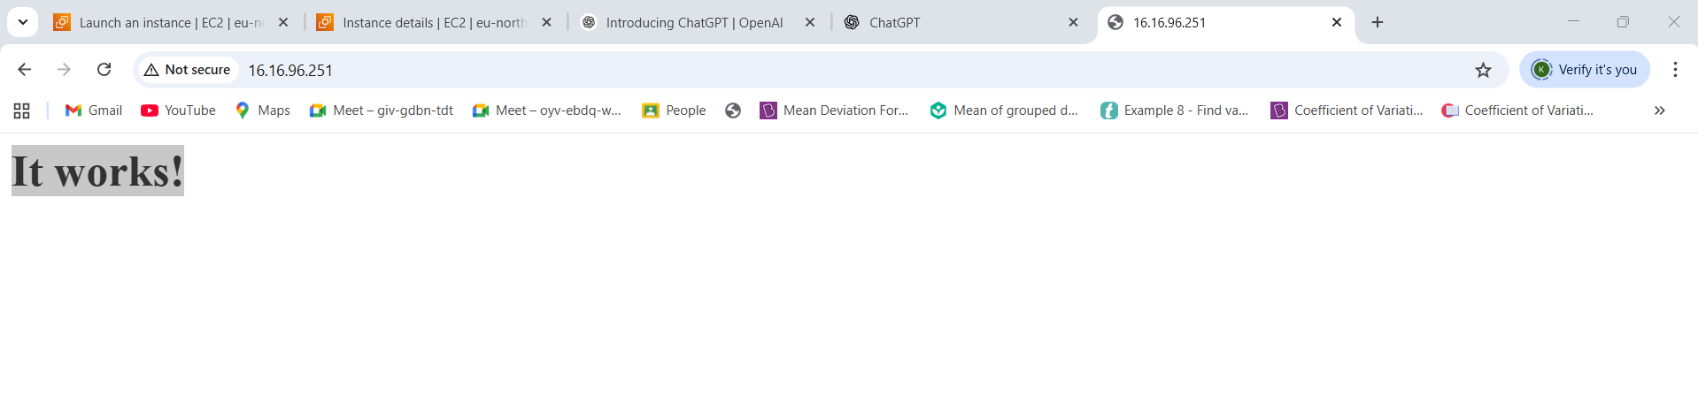
Commands used: find – to find the path of directory, cd – to change directory of path, vi – to edit the port in path
This webserver is running on default 82 port number
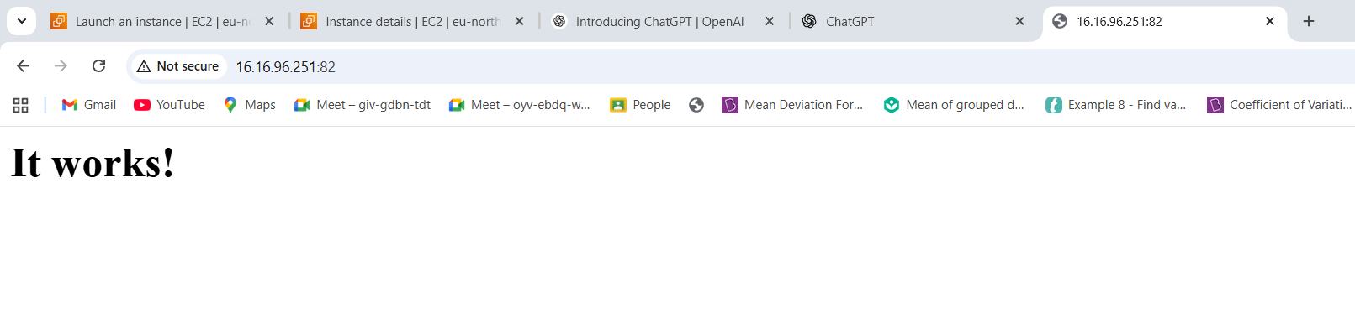

Created a html file in Apache
button feature that show the terminal server and port id
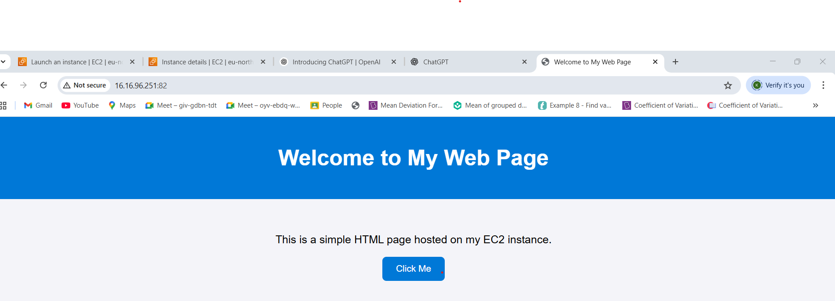
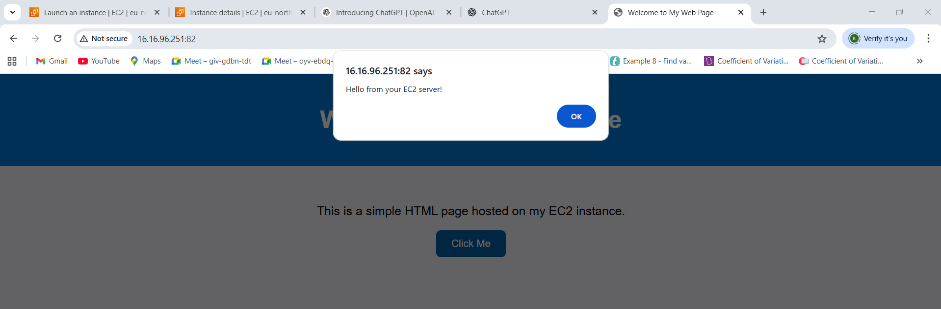
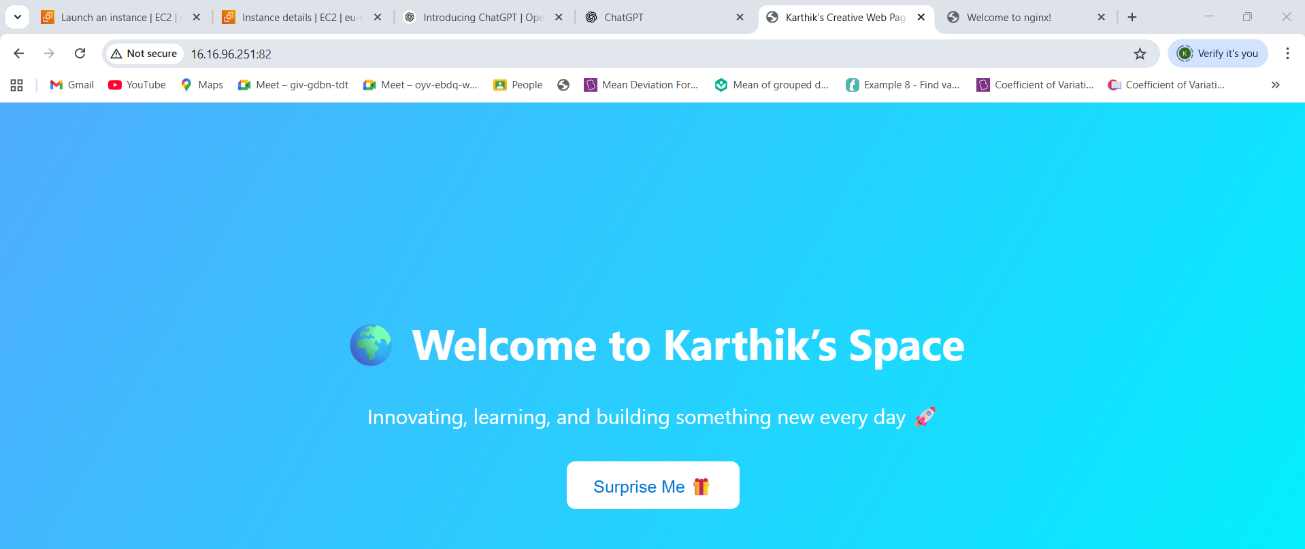

NGINX
Install nginx and run the httpd using AWS instance and gitbash
This webserver is running on custom 81 port number
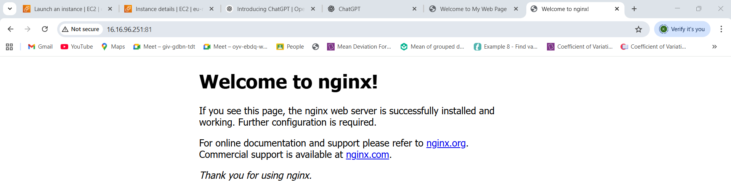

Edit a html file in nginx
Added features that show the web aesthetic
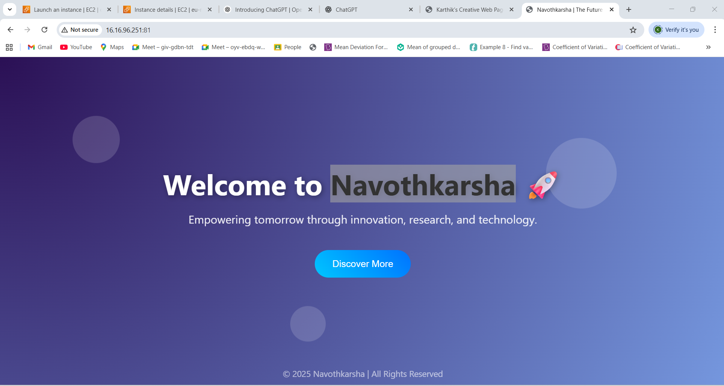

APACHE-TOMCAT
- Install Apache tomcat on port number 8082

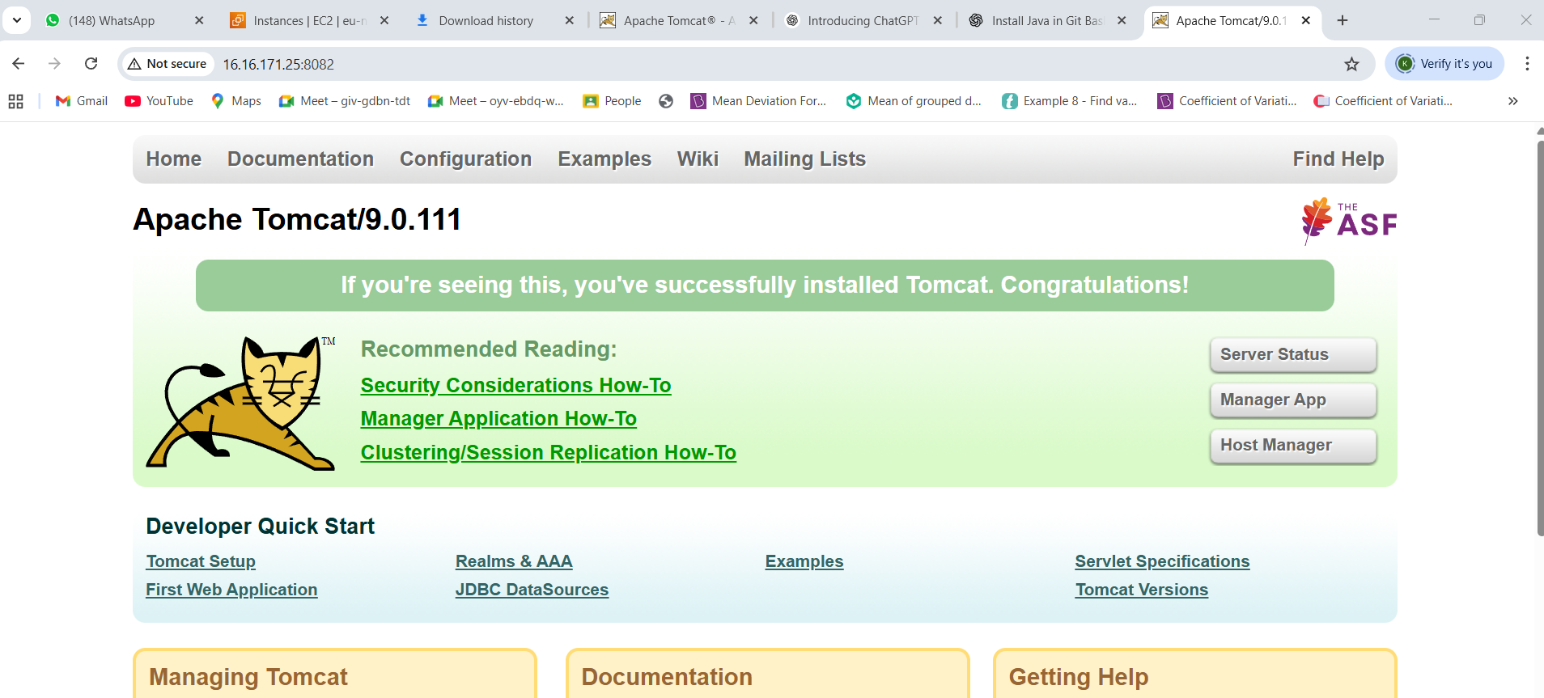

- Deploy a sample app on webapps
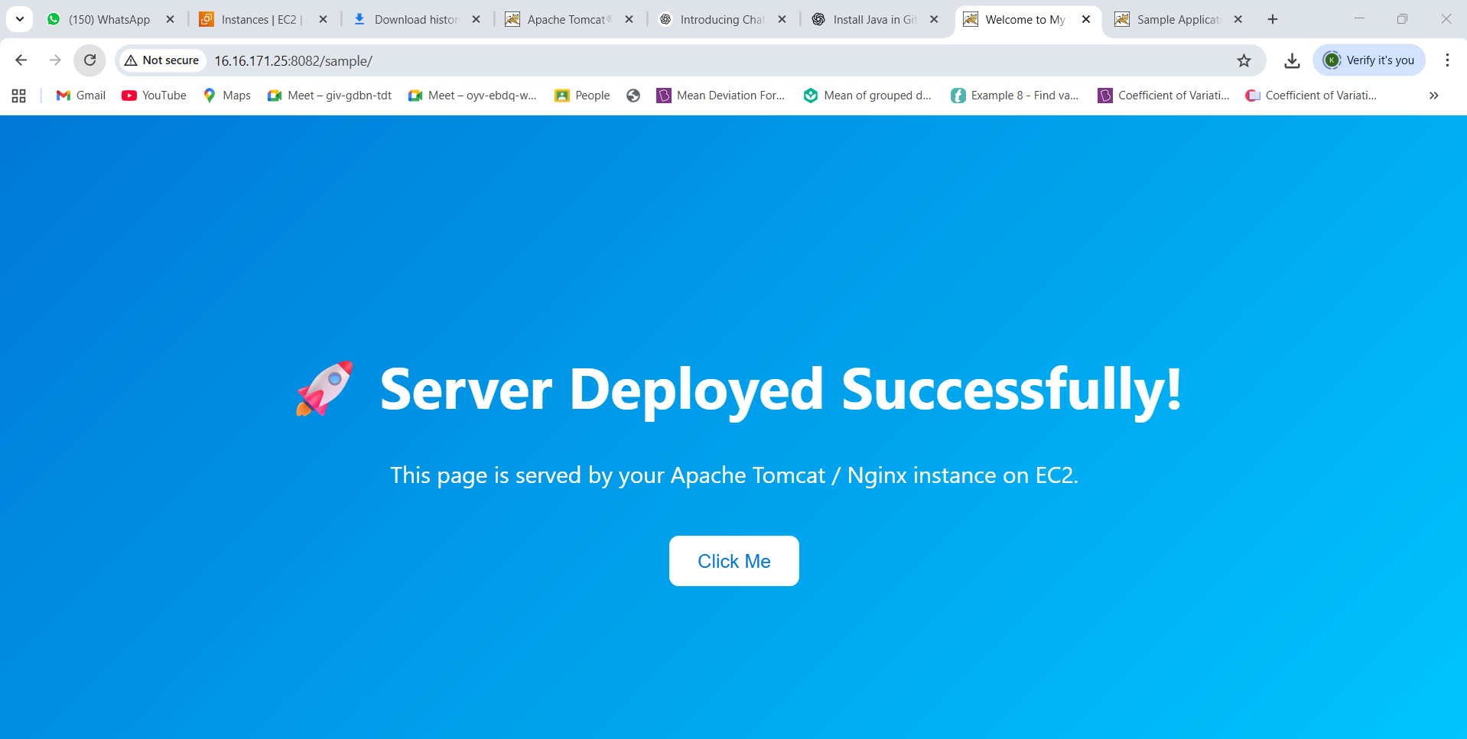

- .Create a tomcat.service file for tomcat.
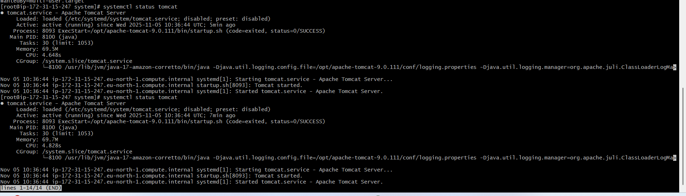

- Configure HA Proxy server
Webpage is Working on public id server-1
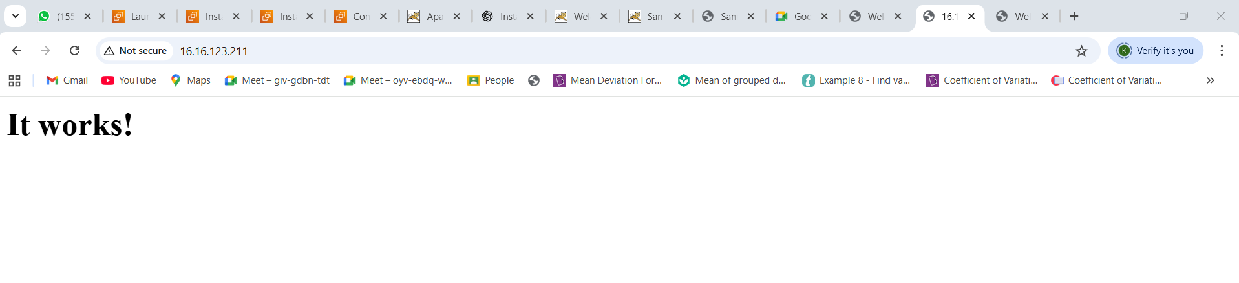
Webpage is Working on public id server-2
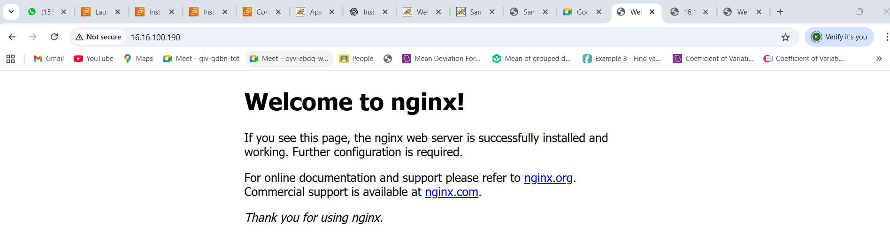

Webpage is Working on public id Ha proxy server
